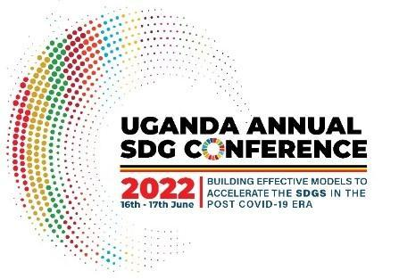

**UGANDA ANNUAL SUSTAINABLE DEVELOPMENT GOALS CONFERENCE 2022**

**Exhibition Request Form**

**Name of Requesting Organization(s)/ Individual(s):** __________________________________________

**Contact Person:** _______________________________________________________________________

**Address:** _____________________________________________________________________________

**SDG(s) of Focus:** _______________________________________________________________________

**List Items and/or category of items for exhibition:** ___________________________________________

*(Please attach a detailed description of the exhibition, no more than one (1) page in length that includes thematic focus of the exhibition and its potential contribution to the conference and SDG implementation in Uganda.)* The exhibitions will take place alongside the main conference on June 16-17

**Equipment and Services** (Please tick equipment required. Please note that laptops are not provided)

Tent:________________________________________________________________________________

Chair and Desk: _______________________________________________________________________

Other Services (Please Specify): ___________________________________________________________

**Submission of Request Form**

Name of Contact Person: ________________________________________

Signature: ____________________________________________________